Paper Title

2018 International Conference on Big Data and Artificial Intelligence

ECG Signal Classification with Deep Learning for Heart Disease Identification

1. **Preprocessing: Filtering & Segmentation**

Using **Wavelet Transform**.

1. **Feature Extraction**

Deep Learning Approach in the next point.

1. **Classification & Classifier**

**A multi-layer 1-D CNN** with pooling layers, dropout layers and fully connected layers. The network takes a time series of ECG signal as input data, and outputs a sequence of label prediction. The network consists of 12 layers including 4 1-D convolution layers.

1. **Accuracy**

Positive Predictive Value: **0.977**

Sensitivity: **0.976**

F1 Score: **0.976**

1. **Two Leads or One Lead ? In case of two leads .. how classification of two leads is merged to have final decision ?**

Using **1-Lead** ECG Signal.

1. **Classes**

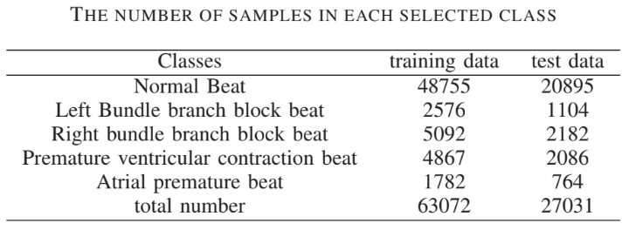**Five** Classes